**Toyo_Toys**



**Toyo_Toys**

CONTENTS

1. Introduction__________________________________________

2. Objectives____________________________________________

3. Problem Statement_____________________________________

4. Hardware/ Software Requirements________________________



**SUBMITED BY**

* **BILAL AHMED**
* **ABRAR AHMED**
* **MEESAM ALI**

Of batch **PR2-202211E**have successfully completed the given task for the topic

**FACULTY: SIR FAIZ**

SEMESTER CPISM

APTECH LEARNING SHAHRAH-E-FAISAL

**INTRODUCTION**

The thirst for learning, upgrading technical skills and applying the concepts in rea life environment at a fast pace is what the industry demands from IT professionals today. However busy work schedules, far-flung locations, unavailability of convenient time-slots pose as major barriers when it comes to applying the concepts into realism. And hence the need to look out for alternative means of implementation in the form of laddered approach. The above truly pose as constraints especially for our students too! With their busy schedules, it is indeed difficult for our students to keep up with the genuine and constant need for integrated application which can be seen live especially so in the field of IT education where technology can change on the spur of a moment. Well, technology does come to our rescue at such times!!Keeping the above in mind and in tune with our constant endeavour to use Technology in our training model, we at Aptech have thought of revolutionizing the way our students learn and implement the concepts using tools themselves by providing a live and synchronous e-Project learning environment!

**ACKNOWLEDGE**

The thirst for learning, upgrading technical skills and applying the concepts in real life environment at a fast pace is what the industry demands from IT professionals today. However busy work schedules, far-flung locations, unavailability of convenient time-slots pose as major barriers when it comes to applying the concepts into realism. And hence the need to look out for alternative means of implementation in the form of laddered approach. The above truly pose as constraints especially for our students too! With their busy schedules, it is indeed difficult for our students to keep up with the genuine and constant need for integrated application which can be seen live especially so in the field of IT education where technology can change on the spur of a moment. Well, technology does come to our rescue at such times!! Keeping the above in mind and in tune with our constant endeavour to use technology in our training model, we at Aptech have thought of revolutionizing the way our students learn and implement the concepts using tools themselves by providing a live and synchronous e-Project learning environment!



**WHAT IS THIS E-PROJECT?**

e-Project is a step-by-step learning environment that closely simulates the classroom and Lab based learning environment into actual implementation. It is a project implementation at your fingertips!! An electronic, live juncture on the machine that allows you to

* Practice step by step i.e. laddered approach.
* Build a larger more robust application.
* Usage of certain utilities in applications designed by user.
* Single program to unified code leading to a complete application.
* Learn implementation of concepts in a phased manner.
* Enhance skills and add value.
* Work on real life projects.
* Give a real life scenario and help to create applications more complicated and useful.
* Mentoring through email support.

**OBJECTIVE OF THIS EPROJECT**

The Objective of this program is to give a sample project to work on real life projects. These applications help you build a larger more robust application.

The objective is not to teach you JavaScript/Dreamweaver but to provide you with a real life scenario and help you create basic applications using the tools.

You can revise the chapters before you start with the project.

This project is meant for students who have completed the module of Dreamweaver. These programs should be done in the Lab sessions with assistance of the faculty if required.

It is very essential that a student has a clear understanding of the subject. Students should go through the project and solve the assignments as per requirements given.

Kindly get back to eProjects Team in case of any doubts regarding the application or its objectives.

**PROBLEM STATEMENT**

TOYO Toys is selling various types of Toys. Company has a huge collection of Toys for different segments of kids. The company advertises by distributing the pamphlets, advertising on television and so on. Due to rapid development in internet field, the company decides to launch a website where people will get all the information about the various products available with them easily.

**Requirement Specification:**

The Web site is to be created based on the following requirements.

1) Home Page should contain logo of the site with proper sections and details of toys with suitable images.

2) The site should display a menu which will contain the options for brief introduction about the various toy products available, location of the shop and any other information if required.

3) The information should be categorized according to the brand names of the products like if a User wants to see only “MATTEL” products or any other companies products then he/she can click on a Link/button/menu etc and can see only that Brand products.

4) Another category option for Age Group of kids should be created and

accordingly the toys should be listed.

5) When a user selects any particular brand, a list of products for that brand will be displayed

6) A brief summary of features of individual products should be displayed on the Web Page along with the product but detailed Features should be stored in Individual Word documents which can be downloaded or viewed by the User who wishes to see the same.

7) The user should also be able to compare the various products of different as well as similar brands.

8) There should be a “Contact Us” page which will have the Address of the Company which is as follows and the mail address which when clicked will invoke the local mail client from where they can send an email.

**Hardware/Softwere Requirements**

**Hardware**

* A minimum computer system that will help you access all the tools in the courses is a Pentium 166 or better
* 64 Megabytes of RAM or better

**Software [Either or Combination as per Course/Sem]**

* Notepad/HTML editor/CoffeeCup
* Angular / Angular JS / React / BootStrap
* Dreamweaver / Figma
* MS IE / Chrome / FireFox / Netscape /MS Edge

**PROJECT ANALYSIS**

|  |  |
| --- | --- |
| NAME | ENROLLMENT NO |
| BILAL AHMED | Student 1432787 |
| ABRAR AHMED | Student 1432788 |
| MEESAM ALI | Student 1428715 |
| TEACHER: SIR FAIZ | BATCH CODE: **PR2-202211E** |

|  |  |  |  |  |  |
| --- | --- | --- | --- | --- | --- |
| NAME | HOME  PAGE | CONTACT  PAGE | PRODUCT  PAGE | COMPARESION  PAGE | INTRODUCTION  PAGE |
| BILAL |  |  |  |  |  |
| ABRAR |  |  |  |  |  |
| MEESAM |  |  |  |  |  |

**Usage of navbar and footer:**

Navigation bars and footers are the basic need of a website now a days so to fulfill this particular requirement we have designed navbar and footer in such a way that you can easily navigate on our website without any problem more information is given below:

Navbar:

images are attached below for better understanding:



Footer:

Our footer is divided into four parts **About Us, links , quick links contact**  quick links are hyperlinked from where you can navigate from one page to another page .And also you can connect with us on

Social media

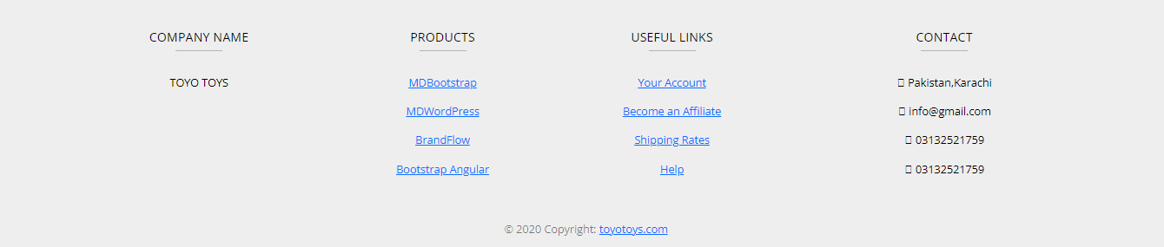

**Home Page Source Code:**

